Sept. 26-Oct. 1
Ms. Vincent’s Class
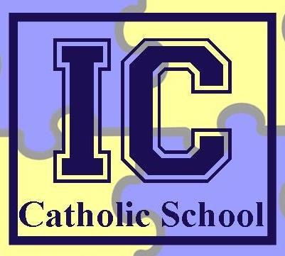

Upcoming Assessments

September 27
Religion Test, The Story of Joseph and related material, Study Guide went home MONDAY

October 1
Math Quiz—Division of larger numbers
Science Quiz—Properties of Light, Study Guide goes home THURSDAY

Important Announcement
Clubs start this week! If you child has signed up for a club, please plan to either pick your child up the day of the club at 4:30 or make arrangements with After School Care.

dvincent@icaugusta.org
Dear Parents and Guardians,
This is another busy week for students and teachers here at ICCS! This is the first week that Fall clubs are meeting, so if your student has signed up for a club (or 3 or 4!), be sure that you have made plans to pick them up at 4:30 instead of 3:30 on that day. Also, lunch menus for October go out today (Monday), so make sure you get those back in by Friday. Thank you again for allowing us to work with your children—we’re blessed to have them!
Thanks,
Ms. Vincent

What’s Going on This Week?
Spelling and Grammar: Forming Plural Nouns Review
Science: Exploring light and its properties
Math: Prime vs. Composite numbers, and division of 3 and 4 digit numbers
Religion: Finishing up the Story of Joseph and beginning a discussion of Communities and the Story of Ruth
Reading: Continuing with our novel Wonder
Writing: Building a Better Written Response to Literature

